# Phase 4 Project

# Online Test Application

* Git Url- https://github.com/IshaanGautam1/Phase4Project
* The project requires 2 Json files, one for questions and other for answers in the following format
* questions.json-
* 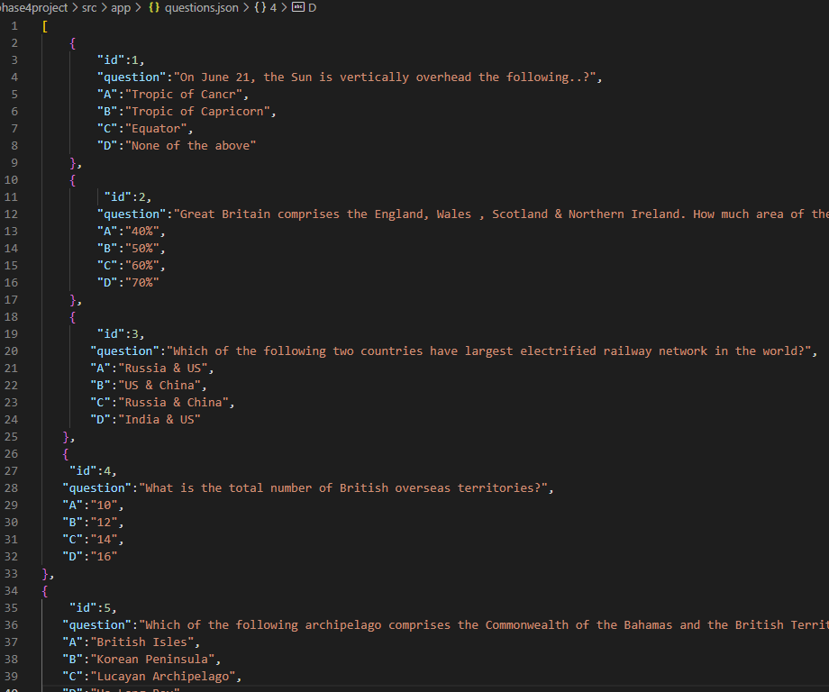
* Answers.json-

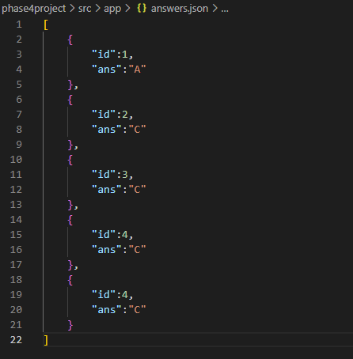

* The application runs on localhost:4200
* 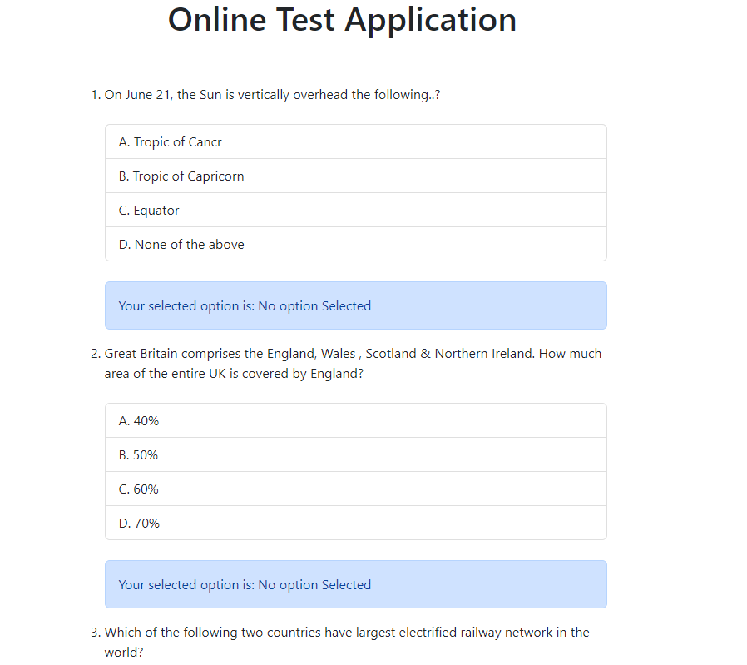
* The user is required to answers, otherwise he will receive an alert.
* 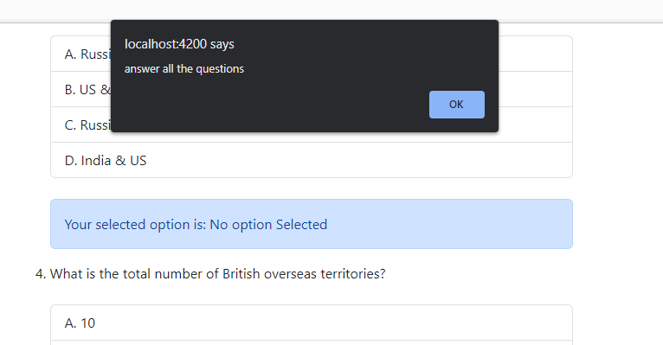
* After selecting all the answers and submitting, the total score will be displayed along with right and wrong answers
* 